**SQL**

Database:

1. It is collection of meaningful data.
2. It is group of objects (table, value, synonyme, UDF, Procedure, trigger, etc).

DBMS:

DBMS is management system which manages the data base objects and data as well.

Activities:

1. Create
2. Inserting data
3. Deleting data from the objects
4. Retrieve/select data from the objects

Database software:

The software is used for doing DBMS/RDMS activities is called database.

RDMS: Relational Database Management System

Relationships between the database objects.

DBMS:

Ex: MS-Access, D-Base, Foxpro, etc.

RDMS:

Ex: Oracle, MS-SQL, Server, IBM DB2, MySQL (free source), sybase, Teradata, etc.

Hadoop Bigdata:

Hive, Hbase, Pig

SQL (Structured Query Language):

Database:

1. DB Client
2. DB Server

SQL Tutorial: <https://www.w3schools.com/sql/sql_intro.asp>

**Database Testing**

**Part1: Database Testing Overview.**

Database – store area

SQL

Frontend – UI

Backend Testing – API

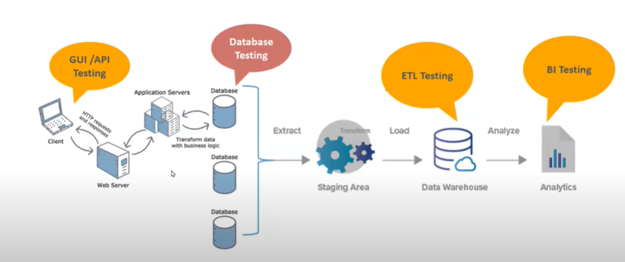

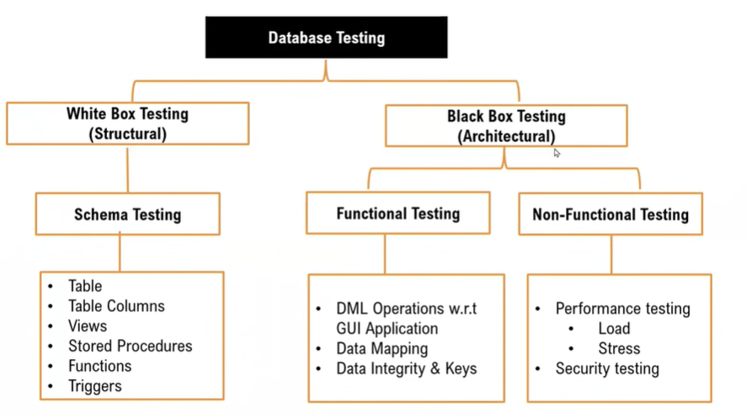

**Part1: Database Testing Overview.**